# Project support worksheet: Turning the Shopping list App into a Playlist App

# The task

In this part of the project you build on the tasks included in the worksheet from term 2 week 10 - **Arrays in App Lab**. In the worksheet you built a Shopping List App that looked something like this:

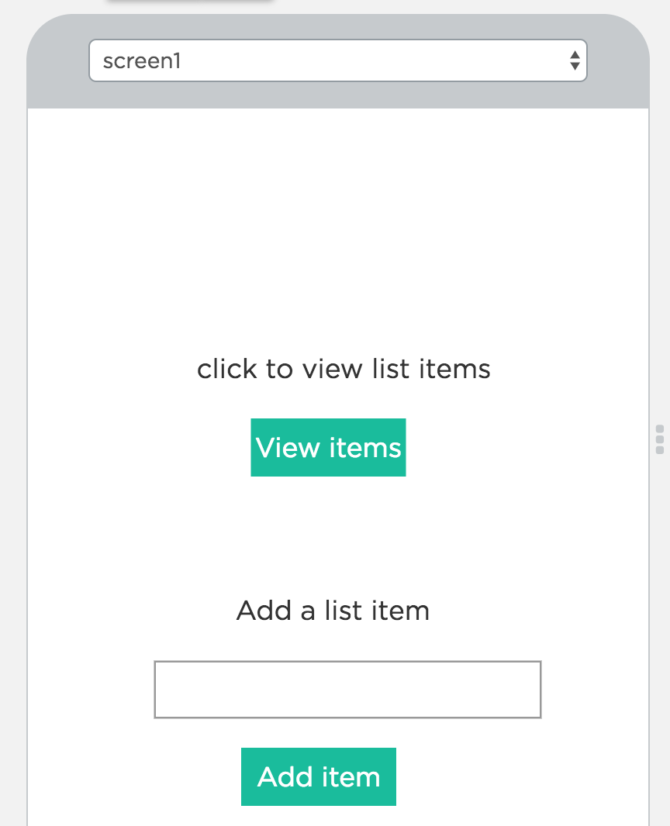

For the project, you are tasked with adapting this into the following:

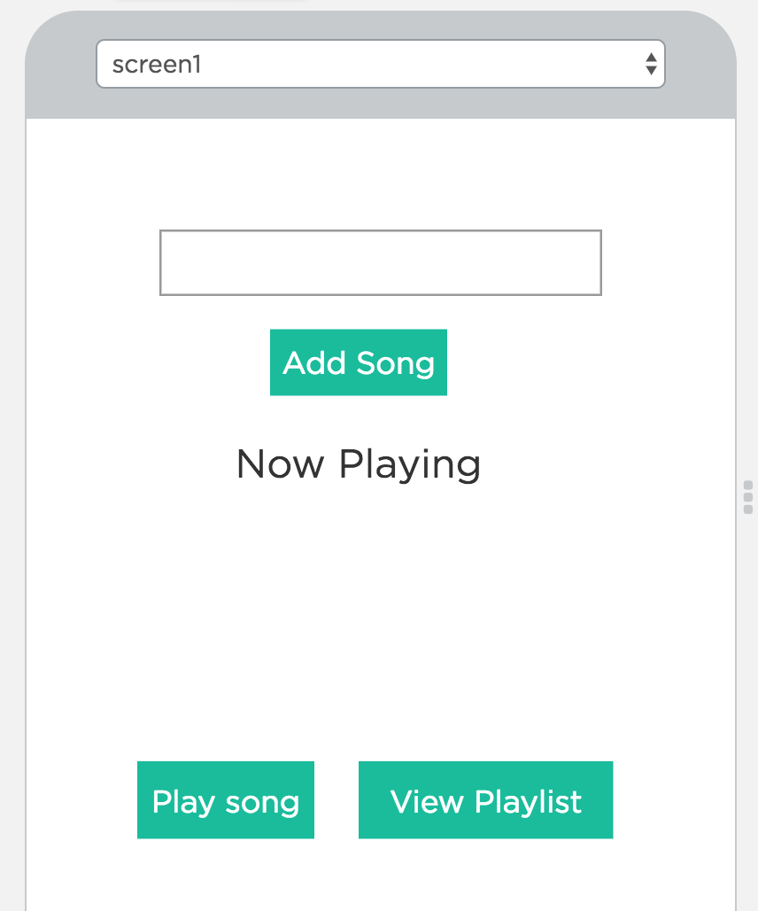

# The task

## Remix

First of all, remix the **arrays** project and call it **playlist**.

## Setting up the UI

Now perform the following tasks relating to setting up the user interface:

* Set up the UI elements (re-naming and changing IDs where necessary) so that they correspond to the **playlist** App screenshot above
* Add an extra button with the text **Play song**.
* Add an extra label to receive the song that is selected as a result of clicking on the Play song button – call it something relevant such as **nowPlayingText**.

## Play song function

This is very similar to the View Playlist function, except instead of displaying the entire Playlist array (converted into a string using the **join** function) you select and display a random item.

To do this, go back to section 2 of the **Arrays in App Lab** worksheet and remind yourself of how to select a random item from an array using the **randomNumber** function in App Lab.

Next using the **setText** function, assign the song that is selected as a result of the Play song function to the **nowPlayingText** label.

To display the random item, again go back to section 2 of the **Arrays in App Lab** worksheet to see the various stages for doing this e.g.

* find out the last index of the array
* assign this to a variable called **max**
* use this as the second parameter of the **randomNumber** function